Download the index.html page from Github | FontysIIW2026/index.html at main · MarkKlerkx/FontysIIW2026  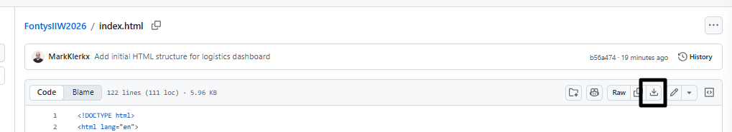
Login to https://portal.azure.com
Go to the “Resource group” page | 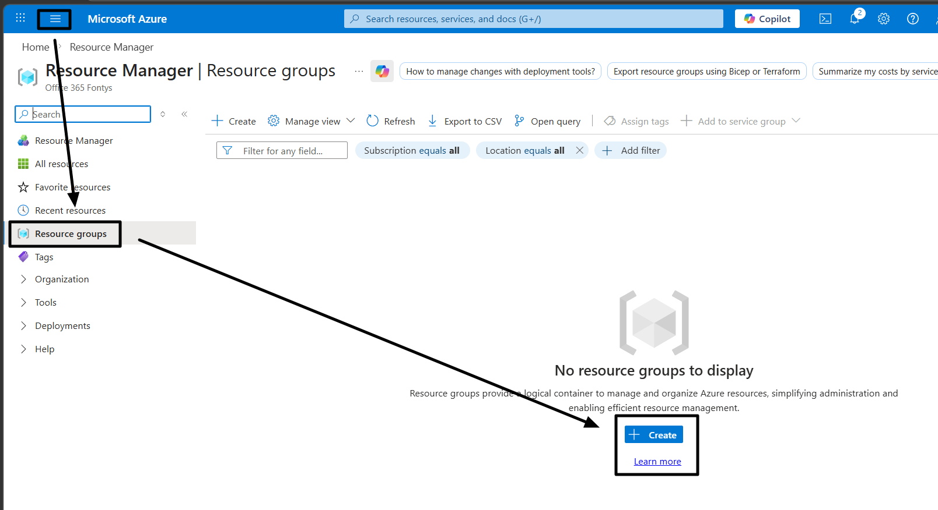
Create a new resource group  Note: select “France Central” as the region | 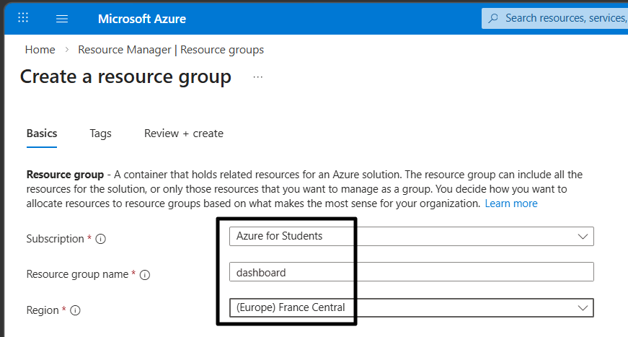
Search “app services” and select the service | 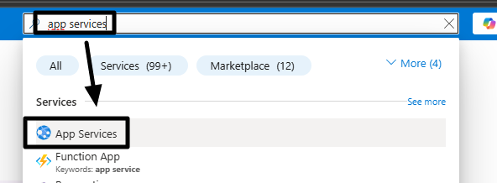
Create your Web App | 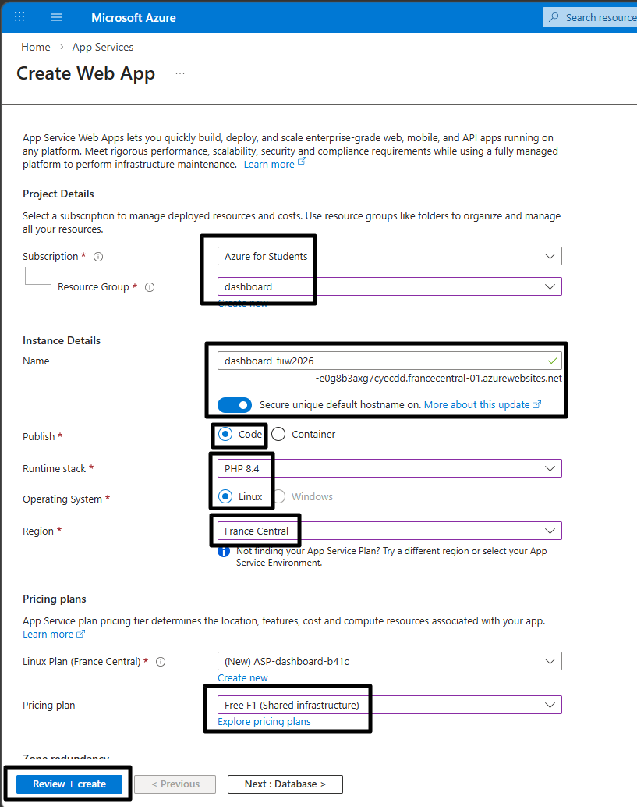
After the deployment, check if the service is running | 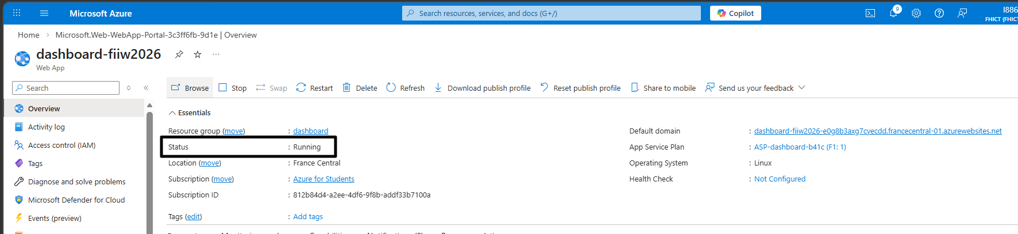
Connect to the App Service with SSH | 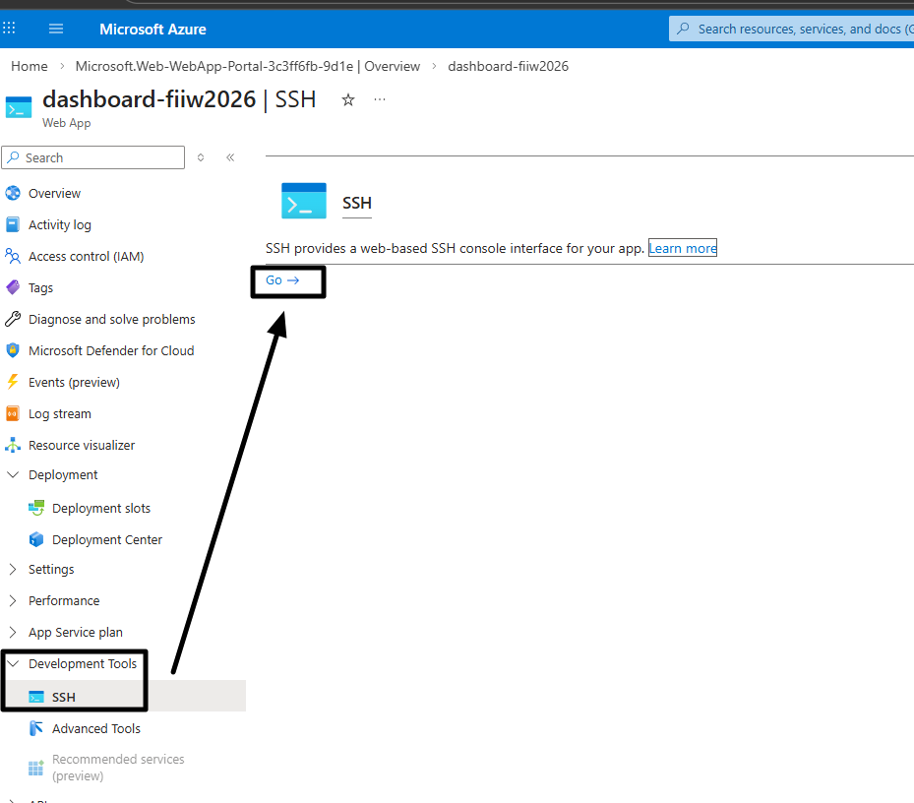
Past the commands in the prompt by pressing the right mouse button in the SSH console  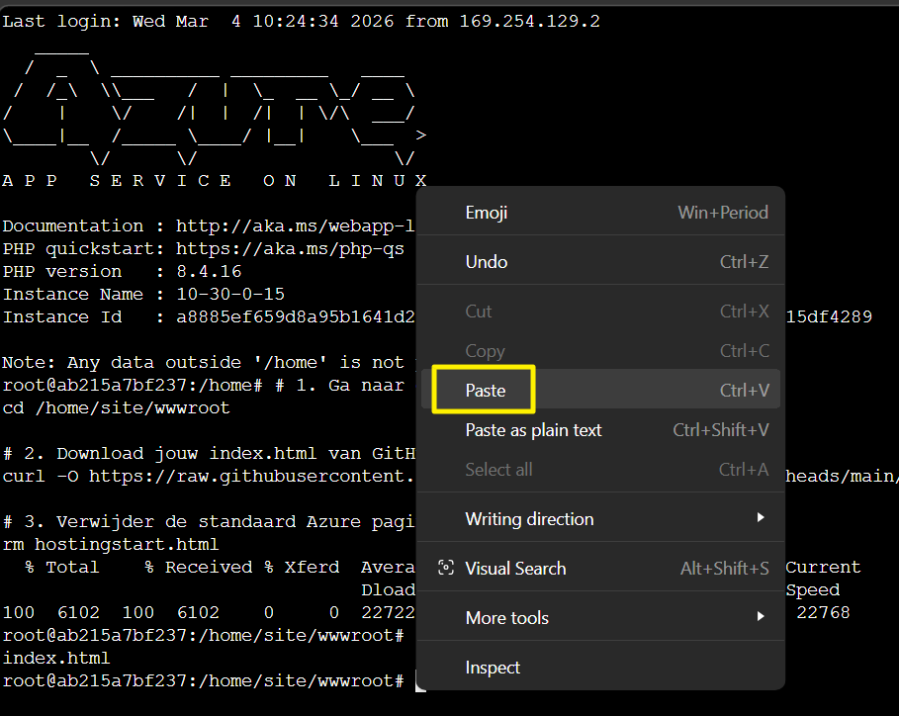 | # 1. Go to the wwwroot folder  cd /home/site/wwwroot  # 2. Download index.html from GitHub  curl -O https://raw.githubusercontent.com/MarkKlerkx/FontysIIW2026/refs/heads/main/index.html  # 3. Remove the Azure default page  rm hostingstart.html
Check your dashboard | 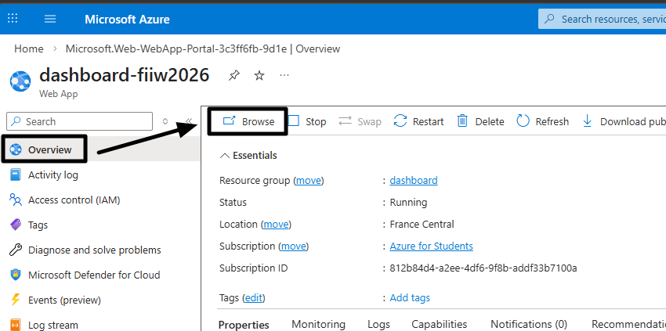
Logon to the dashboard | 